Final Report: Identifying Urban Functional Regions
Author: Joshua Rimes c22002134
Supervisor: Padraig Corcoran

Key: more info on website | to do | ask Padraig

Abstract

Acknowledgements

Table of Contents

Introduction
A good introduction should tell the reader what the project is about without assuming special knowledge and without introducing any specific material that might obscure the overview. It should anticipate and combine main points described in more detail in the rest of the project report. Also, importantly, it should enthuse the reader about the project, to encourage them to read the whole report. Normally it should include such things as:
- the aim(s) or goal(s) of the project,
- the intended audience or “beneficiaries” of the work done,
- the scope of the project,
- the approach used in carrying out the project,
- assumptions on which the work is based and
- a broad summary of important outcomes.

- Define socio-economic
- Define Quality of life (Mercers chart)
- Define Functional region
- Define POI

1.1 Project Aims

Background

2.1 Why is Urban Planning and Layout Important
The significance of this project lies in the importance of layout of urban areas. Cities rely on urban planning to remain functional, grow in population, and attract businesses. Every crucial aspect of an urban environment is under the effect of how its layout is planned (Cesar 2023). On an economic level, a city must meet the needs of workers to retain them and build successful businesses. Companies will set up offices in areas that attract employees and can provide comfort to those employees living close by.
To grow, a city must have a core that can support the expansion of urban areas. In extreme cases such as London, multiple cores form to adjust to the sheer scale of its urban areas. These cores have a focus on corporate and entertainment functions; offices and headquarters are likely found, along with retail and attractions such as shopping centres and cinemas. Outside of the cores, the functionality of urban areas depends on multiple variables discussed in section 2.2.
The ideal urban layout is not a feasible system to achieve; the characteristics of an ideal urban layout system may exist in the absence of external disturbances such as political, social, and economic considerations (Gushchin et al. 2017). However, if a structure or system can be found to improve the growth of a city, we can improve all aspects of life in an urban setting. The potential of growth in a city includes improved health and quality of life, less environmental impact, better economy and resource utilisation, national development, disaster prevention and greater credibility, more efficient problem solving and creativity, and more (Cesar 2023).

2.2 Existing Views on the correlation between socio-economic factors & urban layout
The relationship between urban layout and socio-economic factors has been extensively discussed in planning and development literature. Highly developed cities contribute significantly to the economic health and productivity of society, while poorly planned urban areas often experience negative outcomes such as heavy traffic congestion, inadequate housing, and overstretched infrastructure (Cesar 2023). A well-planned city layout provides access to essential services, amenities, and points of interest, which in turn improves the quality of life and promotes healthier lifestyles among residents (Cesar 2023).
One factor highlighted in modern studies is street accessibility. Research from the Centre for Cities (Magrini 2017) indicates that the street layout of a city can heavily impact its economic success. In their study, a strong positive relationship was found between a city’s street ‘accessibility score’ and its overall economic performance. Cities with more accessible, grid-like street patterns typically facilitate better movement of people and goods, which enhances economic activity. However, this research mainly focuses on street patterns and does not directly address the influence of broader functional regions or points of interest (POI) distributions.
Socio-economic indicators are often used to assess the success of an urban area, but quantifying these indicators can be challenging. Although the concept of quality of life has been in the development discourse for some time now, measuring it in a city is quite difficult as the aspects to be measured are still questionable (Khalil 2012). For example, Mercer’s Quality of Living Survey lists factors such as housing, economic environment, public services, and recreational facilities as key criteria, but achieving a universally accepted standard remains difficult. Urban initiatives often prioritise areas like shelter, access to services, and fostering local economic development to improve living conditions (Khalil 2012).
Another perspective comes from examining how public spaces are used within urban environments. Critiques suggest that analysis of public spaces can sometimes be distorted to fit a particular thesis, and that definitive evidence supporting either positive or negative claims about public space design is limited (Carmona 2010). This implies that while socio-economic outcomes and urban design are linked, drawing conclusions without acknowledging context-specific variables can be misleading.
The current body of research supports the view that socio-economic outcomes are closely tied to urban structure. However, while there is strong qualitative agreement on this relationship, the quantitative evidence remains complex and nuanced. This reinforces the importance of careful, data-driven methods in attempts to identify functional regions and assess their socio-economic impact.
**check this for AI

2.3 Research on Region Identification

https://www.jstor.org/stable/43617893?seq=5
- "Traditionally, geographers and other scientists have used two classificatory viewpoints in defining regions."
- " A region may be composed of areas or locational entities which in some specified respect are homogeneous."
- "the variable(s) upon which the region is defined are attributes of the area being grouped. – this is known as a formal region.
- "a region may be composed of areas or locational entities which have more connection with each other than with other in outside areas … this suggests that the areas comprising the region differ so as to be functionally complementary to each other. Such a region is termed a functional region."
- If one was to look at the interaction between areas and entities, it might skew the relation and location of the entity within a region in a way that is less binary (this or that region).
- (Brown and Horton 1970) – the flows used for delimiting functional regions are surrogate for the functional distance separating entities. Functional distance derives from mapping the n properties of each entity in an n-dimensional space, the computing a measure of distance separating any two nodes. This reflects the net effect of entity properties upon the propensity of the entities to interact.
- In practice, functional distance is derived directly from interaction patterns.
- Markov chain analysis to flow matrices. MFPT as a measure of functional distance.
- The resulting functional regions from this method was used to find much larger regions than what I would like to focus on in this project.

https://www.sciencedirect.com/science/article/pii/S0303243422000794#ab005
- Classification for buildings included residential buildings – not present in the POI data ill be looking at
- Morphological feature extraction: graph constructed for buildings in a block within an urban district, GCNN (Graph Convolutional Neural Network) built to extract formal features of the block from the buildings in it.
- Socioeconomic feature extraction: The W2V model used to analyse the block-POI structure to find a representation for POI categories. Socioeconomic features for each block calculated by weighing the representations of all the inner POIs.
- Word2Vec (W2V) model creates a representation of each word present into a vector. Words in similar context or similar semantics are closer in vector value.
- Stacking ensemble learning: SE model with 2 base and 1 meta classifiers is constructed to process the morphological and socioeconomic features of each block. An output of the probabilities that the block belongs to a different functional region.

2.4 Research on POI & Socio-Economic Datasets

https://location.foursquare.com
- Foursquare place engine – machine learning to synthesise 16 billion data points to ensure accuracy
- Is not focused on geographical POI data
- Not free for students

https://www.openstreetmap.org/#map=12/51.4828/-3.1610
- Open street map provides detailed mapping for POI and city data
- Not downloadable as far as I'm aware

https://www.precisely.com/product/precisely-points-of-interest/precisely-points-of-interest?utm_medium=cpc&utm_source=Online-Advertising&utm_campaign=Data-Integrity_Global_Digital-Ads-Google-Paid-Search-Brand-Campaign_2025&utm_content=
- POI data
- Not free

https://digimap.edina.ac.uk/roam/map/os
- Map and data delivery service
- Available by subscription to Cardiff University
- Range of datasets for educational and research purposes (educational or research?)
- Loads of POIs
- Downloadable poi dataset
- Level 1: 9 groups, level 2: 52 categories, level 3: 600+ classes
- Data is positionally accurate to 4 levels of accuracy
- Record structure of dataset includes 25 columns (look on website)

https://digimap.edina.ac.uk/roam/map/society
- Societal data: population density, age ranges, professions, employment, health

https://www.ons.gov.uk/search?topics=9731,6646,3845,9497,4262,4128,7755,4994,6885,9724,7367&filter=datasets
- Data from 2021 census: residence type by age

https://www.ons.gov.uk/economy/datalist?filter=datasets&page=4
- https://www.ons.gov.uk/economy/grossdomesticproductgdp/datasets/regionalgrossdomesticproductallnutslevelregions - Regional gross domestic product: all ITL regions
- https://www.ons.gov.uk/visualisations/labourmarketlocal/W06000015/#inactivity - Employment, unemployment and economic inactivity in Cardiff

2.5 Research on POI Data

https://datarade.ai/company/blog/what-is-poi-data
- Representations:
- Coordinate-based - This representation allows for accurate geospatial positioning and mapping of various points of interest. Usually uses latitude & longitude
- Address-based - Each POI is associated with a specific postal address. This method allows users to search and identify POIs based on their textual addresses. More user friendly.
- Categorical - POIs can be categorized based on different criteria, such as their industry, purpose, or classification. This representation allows for grouping and organizing POIs into different categories or types, making it easier to search, analyse, and present the data.
- Hierarchical – POI data can be organised hierarchically based on levels of granularity. This structure allows for efficient organisation and navigation of the data.
- Attributes-based - POI data can include additional attributes or metadata associated with each point of interest. These attributes can provide further information about the POIs.
- Graph-based - In some cases, POIs and their relationships can be represented using graph structures. Each POI is considered a node, and the connections between POIs (e.g., proximity, adjacency) are represented as edges. This representation allows for analysing spatial relationships and performing network-based algorithms on the POI data.

https://www.ordnancesurvey.co.uk/documents/product-support/support/points-of-interest-classification-scheme.pdf
- Existing POI classification
- ‘Accommodation, eating and drinking’, ‘Commercial services’, ‘Attractions’, ‘Sport and entertainment’, ‘Education and health’, ‘Public infrastructure’, ‘Manufacturing and production’, ‘Retail’, ‘Transport’
- 52 categories within the 9 groups
- Could have a colour/symbol for each 9 classes, then a label for the specific categories

Design & Methodology

In this section, I will be discussing the methodology this project will use to ensure that milestones are met. It will also include the justification of the datasets that are analysed and used to create the data comparisons. Some of the Python libraries used to analyse and visualise the data will also be discussed so that their use is justified.

3.1 Methodology
I chose the waterfall methodology for this project as I had clear stages of development from the start. This methodology allows phases to cascade sequentially; only once a phase is completed can the next phase start (Atlassian [no date]). Although the waterfall method is rigid and does not incorporate the ability to revisit earlier phases like the agile method does, the obvious structure of this project means the development progress can be tracked more easily, especially with the help of a Gantt chart.
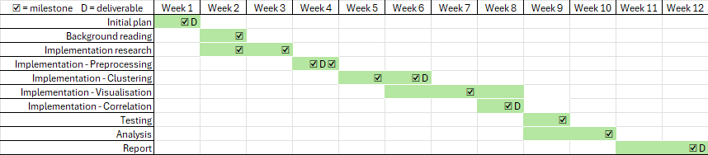
Figure 1. Gantt chart visualising the progression of the project.
The Gantt chart shows a visual plan of the phases within this project. It clearly shows the week-by-week plan for the duration of the project, as well as the milestones and deliverables I set within the initial plan.
The milestones were written as a separate list to ensure that the project was progressing at a reasonable pace. For example, a milestone of making overlay heatmaps to find correlation between POI and socioeconomic data would not be marked complete until a visual map displaying the POI clusters was created. Although these plans and milestones are helpful for structuring a project, things often do not go as expected. Therefore, it is important to remain flexible and mindful of potential obstacles during development. Nevertheless, having a plan was very helpful for organising my work, as I needed enough time at the beginning to research new topics and develop knowledge of niche Python libraries to ensure my skills were adequate for the main development phase.
Since the very start of this project, I had planned to use the Python programming language. There were a variety of reasons for this choice; the main reason being that Python is the language I have the most experience in and the language I felt I could produce the highest quality code in. I also chose Python because of its reputation as a popular language for data processing and analysis. Python boasts a rich ecosystem of libraries and tools specifically designed for data analysis (Karl 2024), making it perfect for building the system required in this project. The Dash Python library provided the core interactive framework for building the frontend web application for this project, this library uses the popular Flask web framework, which is another reason I decided on Python as the language to use for this project.

3.2 Choosing the datasets
For both the POI and socioeconomic data used to draw analysis, Digimap (Digimap 1996) was decided upon as the best source of data. Ordinance Survey data provides the most accurate and detailed POI data out of all the datasets I could have used. The 600+ official predetermined classifications met the level of detail necessary to make valid analysis of the POI clusters. Digimap also provided census data from 27th March 2011, from which a dataset on population age was downloaded. Data from the most recent census in 2021 was not accessible from Digimap and was significantly more difficult to find, hence the decision to continue with data from 2011.
Mention the different datasets for se data and justify them
The datasets from Digimap were downloaded in Comma-separated Value (CSV) file format due to my experience with the format and general ease of use. In the case of this project, using a program such as Excel, made viewing CSV files very straightforward to work with. The system being built to process the data for this project only holds two CSV datasets at a time which relegated the need of a database system such as SQLite since no large datasets or complex relationships needed to be stored. The final justification of the decision to use CSV formatting was its common integration with Python; there are many popular libraries (e.g. pandas) that make CSV files simple to read from and write to.
The third dataset required for the system held the data for the areas used for the overlays of socioeconomic data. My plan was to use the Office for National Statistics’ statistical geographies to divide the cities up into Super Output Areas (Statistical geographies - Office for National Statistics 2021). Lower Super Output Areas (LSOAs) comprise of between 400 and 1,200 households, while Middle Super Output Areas (MSOAs) comprise of between 2,000 and 6,000 households. Originally, the plan was to use LSOAs because they provide more detailed information on the spread of socioeconomic data as well as aligning better with the size of the POI clusters, however, the sheer quantity of geographical coordinates used to create all the polygons for the LSOA shapes used too much memory on my PC. For the sake of time and specification constraints, MSOAs were chosen to be the geographical areas used for the socioeconomic overlays.
The MSOA dataset was downloaded in the GeoJSON format. GeoJSON is lightweight, human-readable, and well-supported by many mapping libraries, making it ideal for rendering polygonal boundaries like those defining MSOAs. Given the shift from LSOAs to MSOAs due to memory constraints, the GeoJSON format was a practical way to manage and visualise these larger, but fewer, geographical areas without sacrificing spatial accuracy or system performance.

3.3 Comparison of clustering algorithms
Clustering is a fundamental step in the analysis and visualisation of urban functional regions. The aim of this stage was to group points of interest (POIs) into spatial clusters based on geographic proximity, with the goal of identifying clusters that can be correlated to the socioeconomic data. To achieve this, I considered several clustering algorithms, including K-Means, Hierarchical Clustering, and Density-Based Spatial Clustering of Applications with Noise (DBSCAN).
K-Means, while commonly used for spatial clustering, was quickly ruled out due to its inherent limitations. The algorithm requires the number of clusters to be defined in advance, which is impractical when dealing with real-world urban environments where the number of functional regions is unknown and potentially variable across different cities. K-Means is sensitive to outliers and assumes spherical clusters of roughly equal size which is not applicable in the case of irregularly distributed POI data. Hierarchical Clustering was also considered due to its flexibility and interpretability. However, the computational complexity of the algorithm becomes a significant drawback when applied to large spatial datasets. This lack of scalability made it unsuitable for the intended system, especially when integrated with a responsive web application.
I deemed DBSCAN as the most appropriate algorithm for clustering POIs in this project. Unlike K-Means and Hierarchical Clustering, DBSCAN does not require the number of clusters to be specified beforehand. It also handles clusters of arbitrary shapes and is resilient to noise, meaning it can effectively identify outlier POIs that do not belong to any functional region. These characteristics aligned well with the real-world distribution of POIs, where clusters are often irregular and interspersed with isolated points.
An important part of DBSCAN's effectiveness lies in the tuning of its parameters within the scikit-learn Python library: epsilon is the maximum distance between two samples for them to be considered as in the same neighbourhood, and min_samples is the number of samples in a neighbourhood for a point to be considered a core point. The use of DBSCAN was further justified by its seamless integration with the convex hull algorithm used to create polygonal representations of each cluster. This density-based approach complements the construction of spatial boundaries, which helped to create a visually logical way to represent functional regions on the interactive map interface.

3.4 Visualisation and Interactivity
Once a clustering algorithm was chosen, the POI data could be represented as clusters of classified functions. To represent this visually, I opted to use Plotly, a Python library with the purpose of creating interactive data visualisations such as graphs and maps. Plotly’s well documented functions provided a wide range of map types that meant multiple data formats could be visualised using a single map and traces.
The two map types chosen to display the data were scatter maps for the POI data, and choropleth maps for the socioeconomic heatmaps. Scatter maps were ideal for visualising the precise geospatial location of individual POIs, as they allow for each point to be plotted based on its latitude and longitude, with the option to colour-code by classification group. This allowed an immediate visual understanding of how different categories of urban functions are distributed across a cityscape, which paired with the use of lines drawn through the scatter map function, created clear visual representation of the clusters. In contrast, Choropleth maps are designed to represent aggregated data over predefined geographic boundaries, making them well suited for displaying socioeconomic indicators across MSOAs. The colour gradients applied in choropleth visualisations show the relative intensity of variables such as age distribution across the city. When I paired these two map types together, they provided complementary views of the urban environment: one showing granular, categorical distributions of functions, and the other highlighting broader demographic patterns across MSOAs.
To ensure that my plan was followed, I decided to create a web application so that further interactivity and visualisation could be achieved. For this, I used Dash, a Python framework specifically designed for building analytical web applications. Dash allowed me to flawlessly integrate the Plotly maps into an interactive interface, where users could toggle visibility, filter data by category, select different layers of socioeconomic information, and change some of the DBSCAN parameters. Behind the scenes, Dash is built on top of the Flask web framework, which provided the underlying server infrastructure and routing capabilities. This combination allowed me to develop a lightweight, responsive application that could render complex visualisations in a browser environment without the need for excessive front-end development.

Implementation

4.1 Handling the data
Handling the POI data throughout the system pipeline was the first critical stage of my implementation. This consisted of developing functions to clean the data that is inputted, cluster the data, create polygonal shapes for the clusters, and display the map. This section will focus on the preprocessing part of the data pipeline, the visualisation of the data will be covered in section 4.3 of this report.
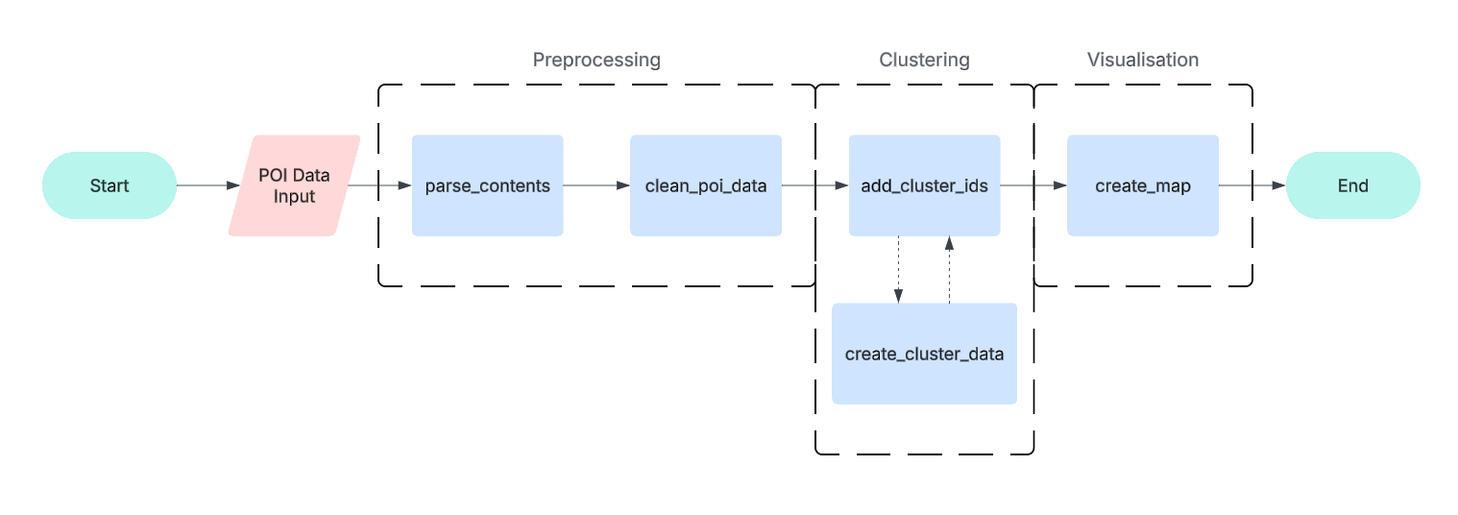
Figure 2. Simple flowchart showing the POI data pipeline
The initial POI datasets that were downloaded included numerous data columns that were not necessary for the system, so the first step was to remove these columns and structure the remaining data. The Python library, named pandas, being used to handle the datasets has a data structure called DataFrame, this structure stores data in a table what can be manipulated by a range of functions that made cleaning the dataset straightforward. I made a function (“clean_poi_data” in Figure 3) to handle all the initial DataFrame manipulation. After the dataset was first downloaded, it was apparent that the records of POIs were being held within one single column, this became an issue that, while easily solvable, meant incomplete records could not be identified straight away. Once the records where split into columns, the “len(data_list)” function could then check to see if the record was complete and drop the row if found otherwise.
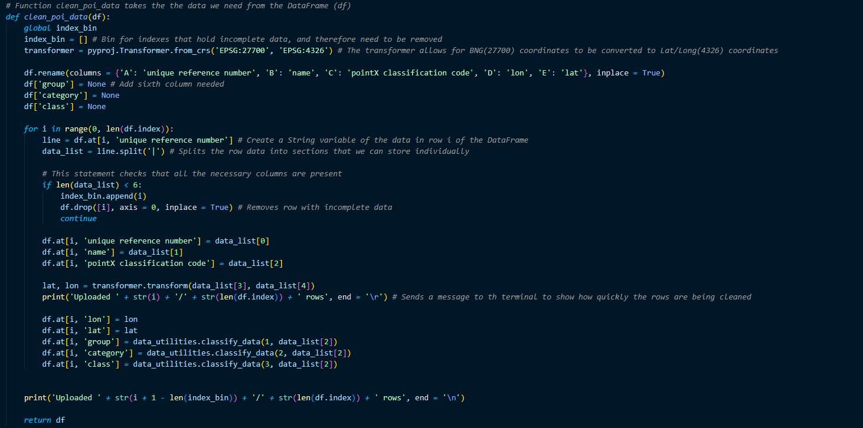
Figure 3. "clean_poi_data" used to clean the initial DataFrame of POI records
The six columns that remained after the “clean_poi_data” function were the attributes deemed necessary to keep. The reasoning behind retaining the unique reference number attribute was purely for testing purposes so that it was clear when observing specific POIs for the correct coordinate placement and other observational tests.
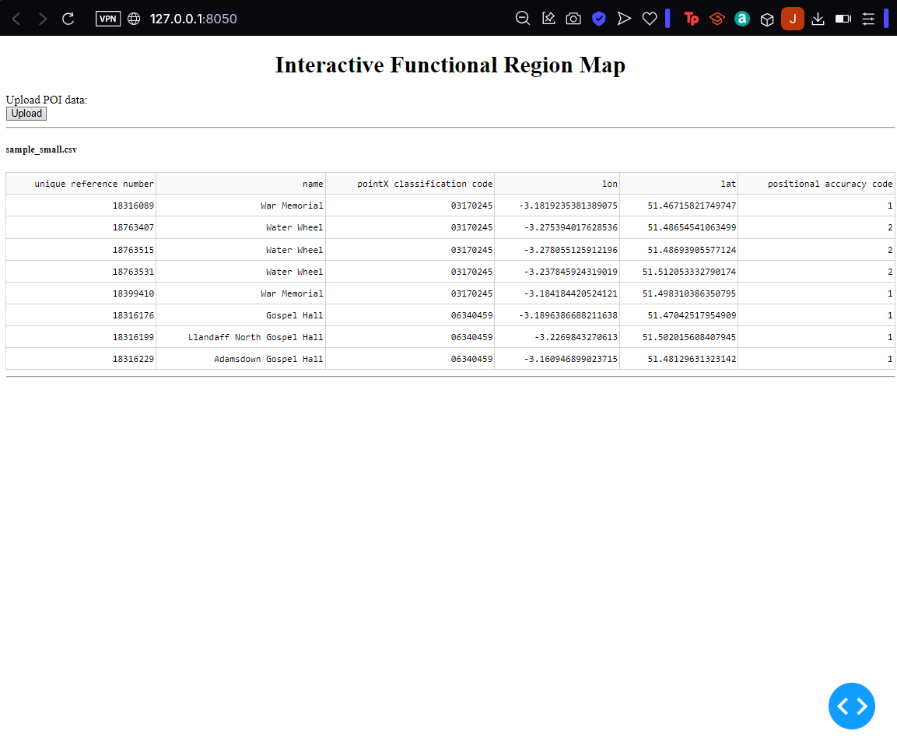
Table 1. Table showing a sample of the cleaned POI DataFrame before adjustments to the function
As seen in Figure 3, the function no longer keeps the positional accuracy code attribute. Given how accurate even a code 3 positional accuracy code is, the positional accuracy of the POIs is a minor issue when taken in the context of larger urban clusters. However, if it was seen as a crucial problem, any POIs with low positional accuracy, for example >= 2, could be filtered out and dropped in the same way the incomplete records are. The other three columns seen in Figure 3 were introduced later in the development of the system. These additions were solely for the purpose of displaying the classification information in the hover data of the POIs. The final POI DataFrame (Table 2) also has the additional cluster id attribute.

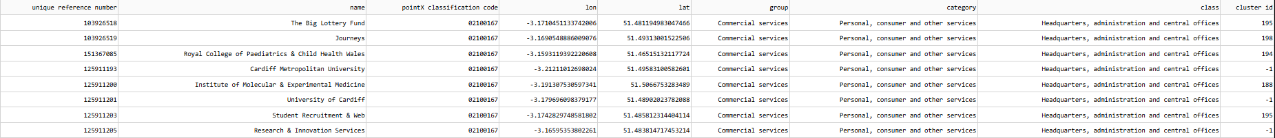
Table 2. Sample from final POI DataFrame
To process the socioeconomic data, the “parse_contents” function was used again to load the dataset into a DataFrame. This dataset also had unused columns, so a similar function is used to minimise the data that is being stored. However, unlike the POI dataset, the downloaded socioeconomic dataset was already separated into columns meaning the only column that needed manipulation was the centroid coordinate column which was then split into latitude and longitude columns.

4.2 Clustering and spatial calculations
When approaching the second stage of the implementation, the distance measurements for the POIs had to be decided on. Within spatial data calculations on a two-dimensional plane Euclidean distance is universally accepted. Euclidean distance is simply the straight line distance between two points. In a plane with p₁ at (x₁, y₁) and p₂ at (x₂, y₂), the Euclidean distance is given by:
d = √((x₂ – x₁)² + (y₂ – y₁)²)
(National Institute of Standards and Technology 2004)
However, since the POIs used the geographic coordinates system, the plane in which the points lie is curved. The haversine formula is a very accurate way of computing distances between two points on the surface of a sphere using the latitude and longitude of the two points. The haversine formula is a re-formulation of the spherical law of cosines, but the formulation in terms of haversines is more useful for small angles and distances (Kettle 2017).
The following equation where φ is latitude, λ is longitude, R is earth’s radius (mean radius = 6,371km) is how haversine(θ) = sin²(θ/2) can be translated to include latitude and longitude coordinates. Note that angles need to be in radians to pass to trig functions:
(Kettle 2017) | a = sin²(φB - φA/2) + cos φA * cos φB * sin²(λB - λA/2)  c = 2 * atan2( √a, √(1−a) )  d = R ⋅ c

Both distance metrics are widely used within spatial data analysis, meaning premade functions for measuring distance with both were readily available in Python libraries such as scikit-learn. However, the scikit-learn DBSCAN algorithm does not have an automatic distance calculator for haversine distance and requires for distances to be precalculated if using the haversine metric. When deciding on which metric to use, the distortion of using Euclidean distance on a spherical plane was considered. On a city scale, the curvature of the plane is ~ 0.09°, and over 100 meters, that curvature would be ~0.0008°. This miniscule angle would likely have insignificant effect on any distance measured with the Euclidean metric. Ultimately, I decided on using Euclidean distance for the sake of efficiency as I would not have to precompute any distance values before clustering.

Having chosen the DBSCAN clustering algorithm, further research was done on the mathematics and parameters of DBSCAN and the specifics of scikit-learn’s function. The algorithm finds core samples of high density and expands clusters from them. It is good for data which contains clusters of similar density. It works by categorising data points into three types; core points - which have enough neighbours within a specified radius called epsilon, border points - which are near core points but lack enough neighbours to be core points themselves, and noise points - which do not belong to any cluster.
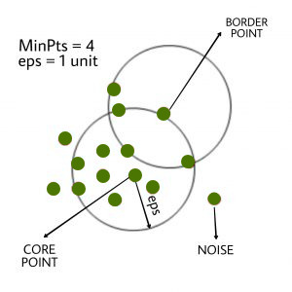
Figure 4. Diagram showing the three points in DBSCAN clusters
In the scikit-learn implementation there are multiple parameters that can impact the size and density of clusters, as well as the metric and algorithm used when computing the clusters. In the system I implemented, only the two parameters mentioned in section 3.4 were considered; the epsilon(eps) parameter was crucial in preventing the clusters from being too large. An eps value of 0.0005 limits a border point to being ~550 meters away from a core point, this meant that a variable eps value between 0.0005 – 0.005 gave accurate and usable cluster sizes on a city scale. The other parameter, min_samples, had to be adjusted according to what was assumed to be enough POIs to indicate a functional region. A min_samples value of ??? was chosen as it stops small areas, for example a row of shops, from being clustered. However, as discussed in sections 5 & 6, small areas like these could also be clustered for comparison to the socio-economy on a lower level. This implementation has a worst-case memory complexity of O(n2), which can occur when the eps parameter is large and min_samples is low, while the original DBSCAN only uses linear memory (Scikit-learn [no date]).
** show screenshots of code for clustering

The final element of spatial calculation for this project was the spatial correlation.
https://realpython.com/numpy-scipy-pandas-correlation-python/

4.3 Creating an app for data visualisation
The final stage of implementation was to create a web application so that the clusters and socio-economic data could be visualised and interacted with. To do this, I started by building a Dash framework which uses embedded html to build the webpage. The Dash framework relies on callbacks to handle how the application reacts to buttons and other interactions. The input and outputs of the application are simply the properties of a component within the layout. When an input changes, the function that the callback decorator wraps will get called automatically. As the system continued to be built, I ran into an issue where the callback function would be re-run every time an interaction. This is usually fixed by sharing data between multiple callbacks, however, a lot of the inputs in the application require calculating and processing the clusters again which makes it difficult to make a multi-callback application.
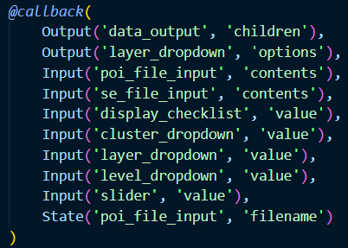
Figure 5. Callback variables for the Dash application
The application has two outputs, seven inputs, and a state for one of the inputs. One output controls the list of socio-economic layers that can be selected from the dropdown, these change depending on the layer columns within the uploaded socio-economic dataset. The other output is the data output which displays the map and data table. As seen in Figure 5, the callback inputs are all components of the application layout. The callback function “update_output” (Figure 6) takes the exact number of inputs as parameters plus optional states, iterates through the data pipeline if there is an uploaded dataset, and returns the exact number of outputs within the callback.
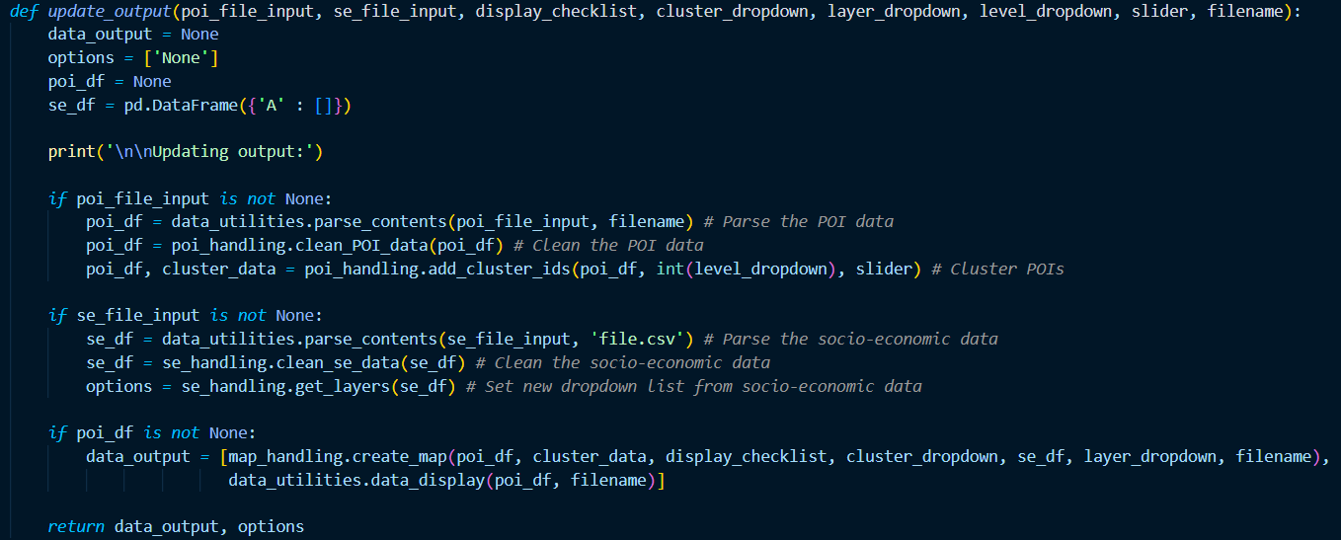Figure 6. "update_output" controls output to the Dash layout
Once the callbacks had been established, I focused on the layout and components needed for the application. Uploading the POI dataset was necessary before any data processing or visualisation could be done so I started with implementing a Dash Upload component. To test whether the data had been uploaded, the application would display the uploaded and cleaned dataset as a table in the application (Figure 7).

Figure 7. Dash application showing upload button and data table
After confirming that a POI dataset could be uploaded, the focus shifted to creating a scatter map to display the POIs. The Plotly “scatter_map” (Figure 8)function takes in a dataset that is used to find the coordinates and other attributes of every record. “hover_data” is a list of information displayed in a small box about a POI when the mouse is hovering over it. The “color” variable is defined by the group in which the POI is classified, each colour was chosen from the standard Python predefined colour chart. The scatter map style was set to the open street map, this was one of a few options for showing areas outside the United States of America and suited the level of detail this application required to make sense of the POIs when displayed on a map.
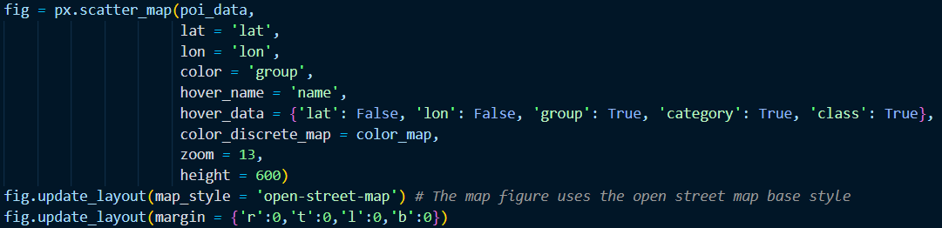
Figure 8. Scatter map creation
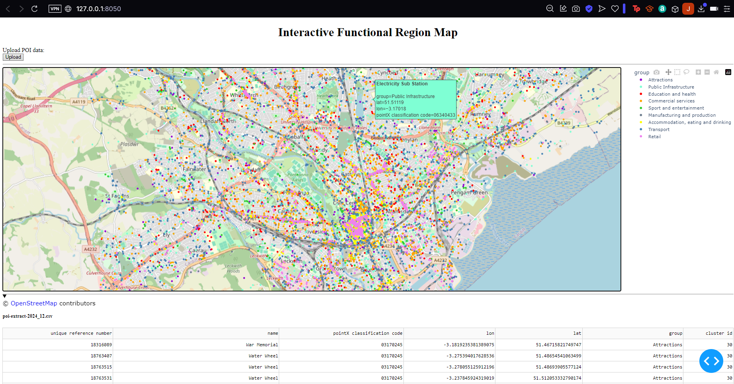
Figure 9. Dash application showing the map with POIs
Next, the clusters were added to the map along with some components for changing the cluster visibility and eps value. When the clusters were first displayed on the map, they would appear as rectangles based off the furthest border point east, west, north, and south in each cluster. After debugging the system, the issue was found to be with the convex hull algorithm being used to create the shape of the clusters; The boundary points were not being appended correctly to the lists of latitude and longitude coordinates. Once this issue was fixed the cluster shapes were being displayed properly (Figure 11).
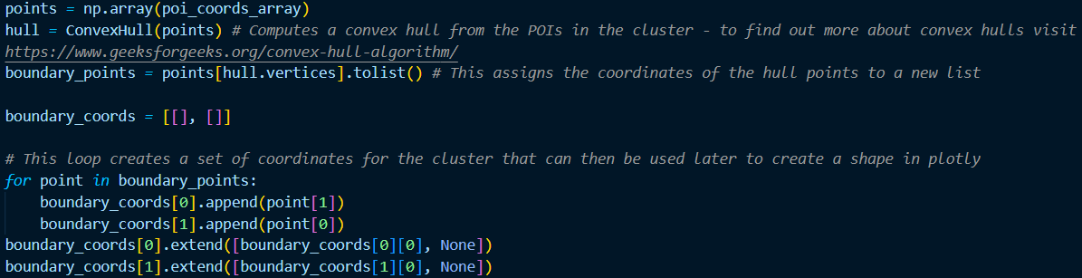
Figure 10. Convex hulls being used for cluster shape generation

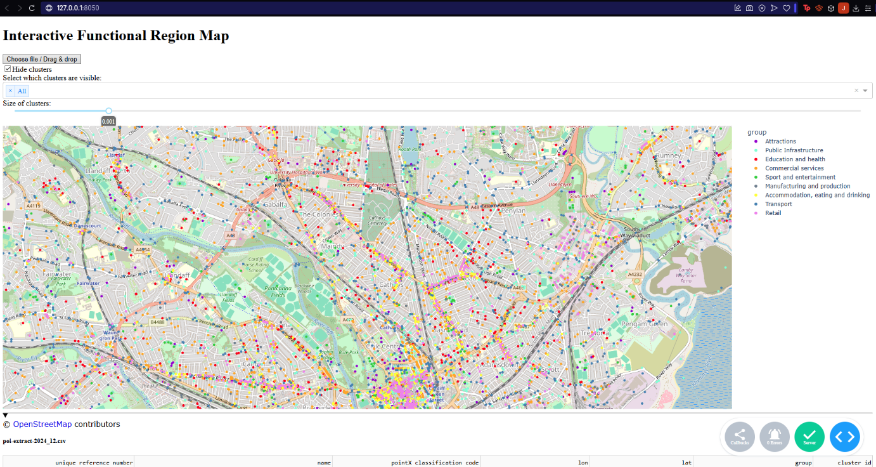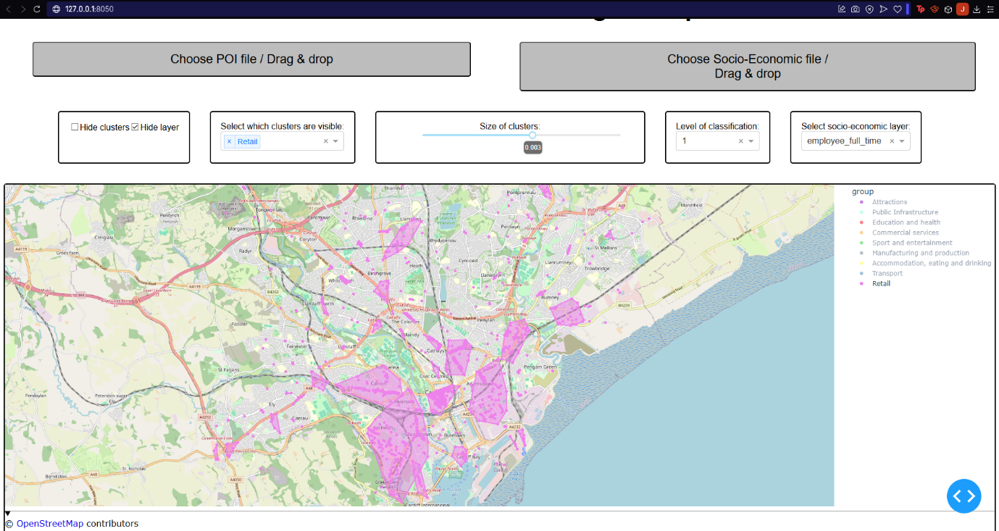
Figure 11. Dash application showing retail clusters on the map
As the number of components within the application grew, a day was spent applying CSS styling so that the application was more user friendly. The importance of styling was in the clarity of the button and other variable components, to make sure this was achieved, adequate spacing was added between the components and the font sizes was increased. Giving each component a border also helped with visual clarity as each interactive feature was contained in it’s own box.
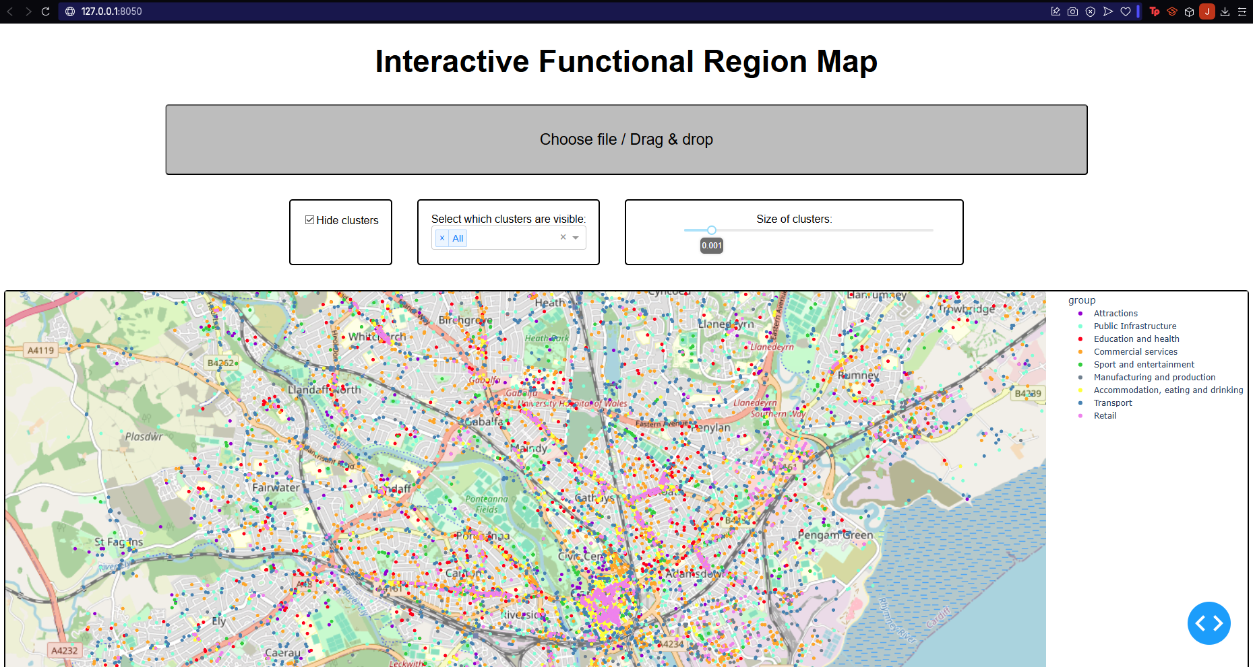
Figure 12. Dash application with CSS styling
The final part of implementing the Dash application was displaying the socio-economic data as an overlay. Before any socio-economic data could be processed or displayed, the geoJSON MSOA objects had to be downloaded. Using the example of Cardiff, 54 MSOA objects were selected to represent the area covered by the POIs. Some of these MSOAs were only partially within the urban area of Cardiff therefore are not covered by POIs. As the choropleth function takes a .json file without any need for preprocessing, there was no need to clean the MSOA data.
Once the data used to make the MSOA shapes, another Upload component was added so that socio-economic datasets could be uploaded to the system. Using the data handling functions made for the POI data, the socio-economic was cleaned and a DataFrame was created to store it. To test whether the socio-economic data was being uploaded, processed, and displayed correctly, the number fully employed individuals was chosen to be a predetermined layer. The choropleth map was then created as a trace of the POI scatter map (Figure 13).

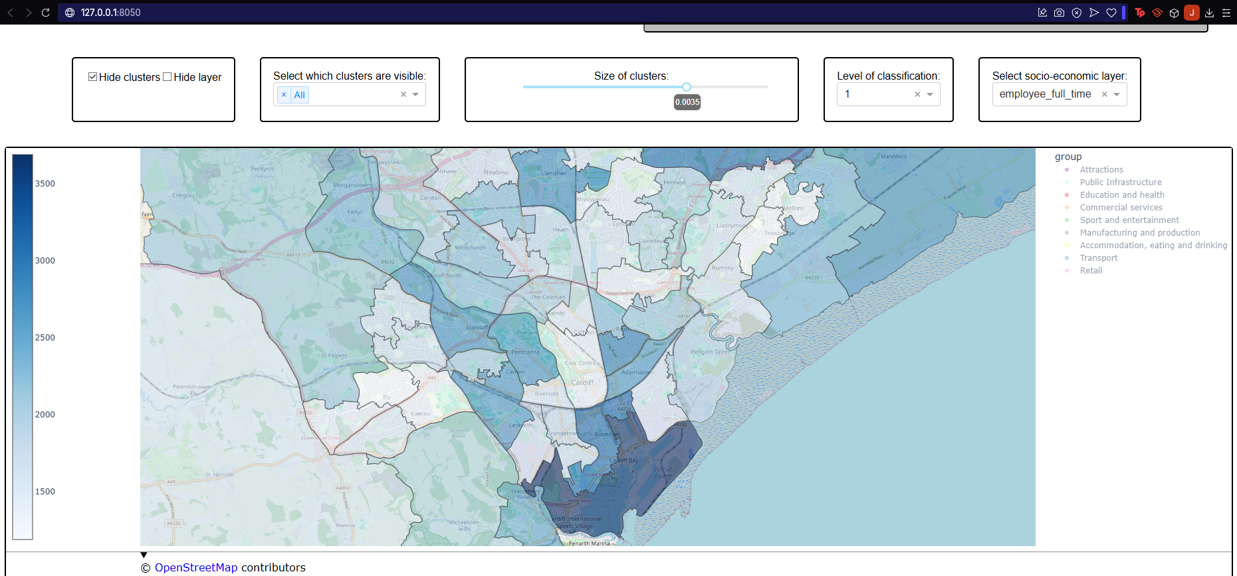
Figure 13. Dash application displaying the employee_fulltime overlay
After confirming that the socio-economic overlays work, I finished the application by creating a dropdown component so that a socio-economic layer can be selected from the layers within the dataset that’s uploaded to the system. I ran into an issue with callbacks where the input value for the dropdown could not be attained as there was not a placeholder value when the application was first initiated. This meant the “update_output” callback function was looking for an input value when it wasn’t there. To handle this issue, a function was made to return the layer columns within the socio-economic DataFrame as a list of values to be used in the dropdown. The dropdown options were also reset every time the application is updated so that there will always be at least a placeholder value for the callback input to use.
**show the application in entirity

Analysis
In this section you should describe to what extent you achieved your goals.
You should describe how you demonstrated that the system works as intended (or not, as the case may be). Include comprehensible summaries of the results of all critical tests that were carried out. You might not have had the time to carry out any full rigorous tests - you may not even got as far as producing a testable system. However, you should try to indicate how confident you are about whatever you have produced, and also suggest what tests would be required to gain further confidence.
This is also the place to describe the reasoning behind the tests to evaluate your results, what tests to execute, what the results show and why to execute these tests. It may also contain a discussion of how you are designing your experiments to verify the hypothesis of a more scientifically oriented project. E.g., describe how you compare the performance of your algorithm to other algorithms to indicate better performance and why this is a sound approach. Then summarise the results of the tests or experiments.
You must also critically evaluate your results in the light of these tests, describing its strengths and weaknesses. Ideas for improving it can be carried over into the Future Work section. Remember: no project is perfect, and even a project that has failed to deliver what was intended can achieve a good pass mark, if it is clear that you have learned from the mistakes and difficulties.
This section also gives you an opportunity to present a critical appraisal of the project as a whole. This could include, for example, whether the methodology you have chosen and the programming language used were appropriate.

Conclusion & Future Work
The Conclusions section should be a summary of the aims of project and a restatement of its main results, i.e. what has been learnt and what it has achieved. An effective set of conclusions should not introduce new material. Instead, it should briefly draw out, summarise, combine and reiterate the main points that have been made in the body of the project report and present opinions based on them.

It is quite likely that by the end of your project you will not have achieved all that you planned at the start; and in any case, your ideas will have grown during the course of the project beyond what you could hope to do within the available time. You can include discussion of future work in the conclusions or as a discussion at the end of the evaluation section. It is for expressing your unrealised ideas, focused in particular of what you suggest as next steps (possibly emerging out of your evaluation). It is a way of recording that 'I have thought about this', and it is also a way of stating what you would like to have done if only you had not run out of time (Remember to take into account Hofstadter’s Law: 'Everything takes longer than you think, even when you take into account Hofstadter's Law.'). Ideally it should provide a starting point for someone else to continue your work.

The Conclusions section marks the end of the project report proper. Be honest and objective in your conclusions.

Reflection
We believe in the concept of “lifelong learning”. One of the principles applied throughout the assessment during your studies is that of the value of reflection. We believe that it is important that we reflect upon our performance in order to identify “transferable learning”, that can be carried over into future activities. Reflection should focus on what Argyris calls “double loop learning”; this is where we identify, not relatively “simple skills”, such as the mastery of a new programming language, but the impact of what we have done on the assumptions, concepts and ideas we used to make decisions about our work. For example, a “reflective practitioner” would try to identify the characteristics of the problem that has been addressed, and consider whether assumptions or decisions about the relevant approach to solving that problem had been appropriate, in order to make a better decision in relation to problems that might be encountered in the future.

Appendices

References

